R O B E R T S T E E L E G A L L E R Y

511 West 25th Street New York NY 10001 212.243.0165

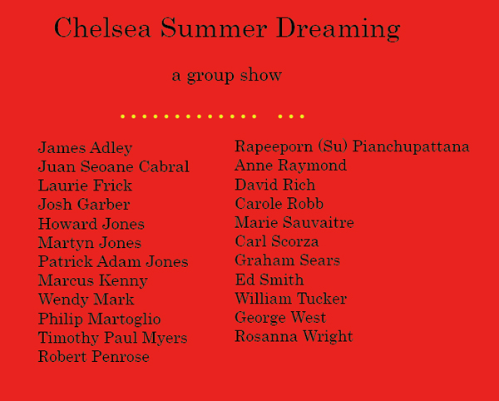

Press Release
Curated by René Grayre

25 July – 18 August 2007

The Robert Steele Gallery at 511 West 25th Street between 10th and 11th Avenues in Chelsea is pleased to announce the opening of Chelsea Summer Dreaming, a group summer exhibition of paintings, sculpture, photography and works on and in paper, opening on Wednesday, July 25th through August 18th, 2007. A reception will be held Wednesday, July 25th from 6 to 8pm and as well on Thursday, July 26th from 6 to 8pm. Gallery hours are Tuesday through Saturday from 11 to 6pm, and by appointment.
- - - - -
Clearly, The Dreaming is many things in one: among them, a kind of narrative of things that once happened; a kind of charter of things that still happen; and a kind of logos or principle of order transcending everything significant for (man).
— Prof. Brian Ackerman, The Dreaming, an Australian World View

We live in strange times. Of course, the case can be made that the collective “we” have always lived in strange times, but these days do indeed seem stranger than most. The glut of information is faster, ever-faster; the stakes are higher, the consequences greater. There’s the sense that we have stumbled yet again upon the crossroads of Chaos and Salvation — except that the Universe really means it this time and the choices we make will have repercussions for decades and generations to come, impacting our environment and the planet, let alone issues like our own domestic politics.

It seems appropriate then, in this sliver of time, to have a visual rumination of sorts (when the going gets tough, the tough look at art?) — a Chautauqua, if you will — to see if we can even begin to discern what the Zeitgeist is wearing of a summer’s evening in this season of Surge and Transition. Chautauquas, of course, were the “traveling tent-shows that used to move across America…to edify and entertain, improve the mind and bring culture and enlightenment to the ears and thoughts of the hearer,” as Robert Persig put it years ago. What better aim for an exhibition, a look at the process which questions, then searches for answers which maybe — just maybe — can help us all find common ground?

The indivisible and enduring relationship of Indigenous people with their lands – to which they often refer in terms of the land owning them, rather than the other way around – go back some sixty thousand years. The Dreamtime is more than just an explanation of how those lands (and all that exists upon them) were created by the Ancestral Beings. It was the start of the Dreamings, the continuing spiritual and cultural processes whereby Indigenous people understand and express their origins and identities, and their connections with the Spiritual Beings, in art and rituals in which millennia disappear and the past is now.
— Di Yerbury, From Dream Time to Machine Time

What might have been and what has been
Point to one end, which is always present.
— T.S. Eliot, Burnt Norton

• • •
The Robert Steele Gallery continues in its mission to engage and refresh, and remains committed.

My thanks to the artists: James Adley, Juan Seone Cabral, Laurie Frick, Josh Garber, Howard Jones, Martyn Jones, Patrick Adam Jones, Marcus Kenney, Wendy Mark, Philip Martoglio, Timothy Paul Myers, Robert Penrose, Rapeeporn (Susu) Piancupattana, Anne Raymond, David Rich, Carole Robb, Marie Sauvaitre, Carl Scorza, Graham Sears, Ed Smith, William Tucker, George West, Rosanna Wright, and to David McKee as well.

Have a good summer, all.

René Grayre
Director,
Robert Steele Gallery

